Date: 03.10.2025
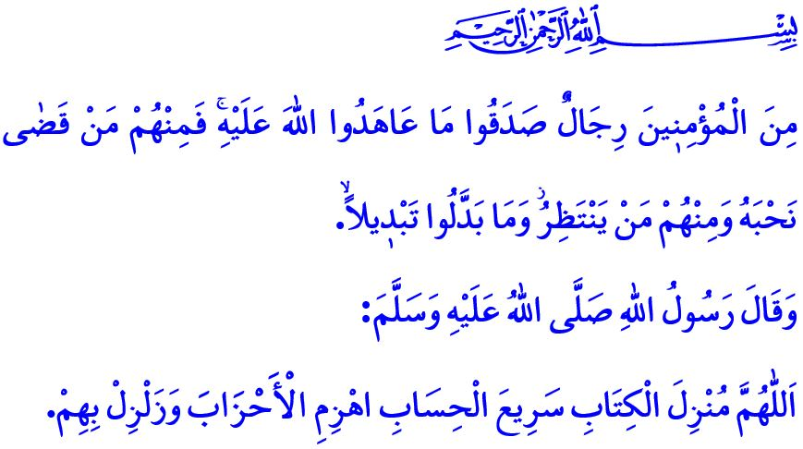FROM THE BATTLE OF THE TRENCH TO GAZA: VICTORY BELONGS TO THE BELIEVERS
Honorable Muslims!
It was the fifth year of the Hijrah. Having been defeated at Badr and failing to fully achieve their objectives at Uhud, the polytheists of Mecca began preparing a massive assault on Madinah in an effort to eradicate Islam and destroy the Muslims. Upon learning this threat, the Prophet Muhammad (saw) consulted with his companions, and it was decided that a trench would be dug around the outskirts of Madinah. As the believers worked together to dig the trench, they encountered a large rock. The Messenger of Allah (saw) personally struck the rock, breaking it apart, and at the same time gave the glad tidings that the palaces of Kisra, the lands of the Byzantines, and San‘a would one day be conquered. After a grueling struggle, by the grace and divine support of Allah the Almighty, and through the determination and perseverance of the believers, the enemy was utterly defeated.
Dear Believers!
Today, a struggle similar to the Battle of the Trench is taking place in Gaza. Just as there were oppressors who persecuted the Messenger of Allah (saw) and his noble companions in the past, today there are tyrants who, before the very eyes of the world and with no regard for any law or principle, are committing genocide against the innocent and the oppressed in Gaza. Mosques, places of worship, schools, and hospitals are being bombed. It is not merely a city but an entire civilization that is being targeted for destruction. Journalists, aid workers, and healthcare professionals are being mercilessly killed.
Esteemed Muslims!
Despite all the adversities experienced, a handful of mujahid Muslims in Gaza are waging a heroic struggle in the trenches they have dug, just as was the case in Madinah, displaying a form of bravery rarely witnessed in the world. As stated in the Holy Qur’an: “Those who were warned, ‘Your enemies have mobilized their forces against you, so fear them,’ the warning only made them grow stronger in faith and they replied, ‘Allah ˹alone˺ is sufficient ˹as an aid˺ for us and ˹He˺ is the best Protector.’” The overwhelming numbers and superior military capabilities of the enemy only serve to deepen their submission to Allah and strengthen their faith. It is as if they are the living embodiment of the verse: “Among the believers are men who have proven true to what they pledged to Allah. Some of them have fulfilled their pledge ˹with their lives˺, others are waiting ˹their turn˺. They have never changed ˹their commitment˺ in the least.” Allah the Almighty never leaves believers who do not stray from the sirat al-mustaqim and who show patience in the face of hardships without support or assistance. وَلَيَنْصُرَنَّ اللّٰهُ مَنْ يَنْصُرُهُۜ “Allah will certainly help those who stand up for Him.”
Dear Brothers and Sisters!
Whenever Muslims responded to the call of Allah and His Messenger, opened their hearts to one another, and acted in unity and solidarity, they overcame all difficulties. But whenever they became divided, failed to care for each other’s struggles, and fell behind in knowledge and technology, their strength weakened, and oppressors began to commit evil without restraint. Allah the Almighty warns us regarding this matter as follows: “Obey Allah and His Messenger and do not dispute with one another, or you would be discouraged and weakened. Persevere! Surely Allah is with those who persevere.”
So then, esteemed Muslims!
Just as in the past, let us continue to stand by the rightful today as well. Let us set aside sectarian and ideological differences and strengthen our unity and solidarity. Let us reinforce our sense of ummah and brotherhood in faith. Let us remain vigilant against those who seek to divide us. Let us support initiatives that demonstrate our solidarity with the innocent. Let us not forget that Gaza is a test of morality and conscience for all of humanity. As the human family, we will either join hands and hearts to pass this test, or we will all fail together.

I would like to conclude this Friday’s khutbah with the following supplication made by the Prophet Muhammad (saw) during the Battle of the Trench: “O Allah, Who sent down the Qur’an and Who brings swift reckoning! Defeat the oppressor groups and scatter them in disarray!”

Nasa’i, Jihad, 42.
Ali ‘Imran 3/173.
Ahzab, 33/23.
Hajj 22/40.
Anfal, 8/46.
Bukhari, Tawhid, 34. General Directorate of Religious Services

